Herbert Spencer Shoaib Ali

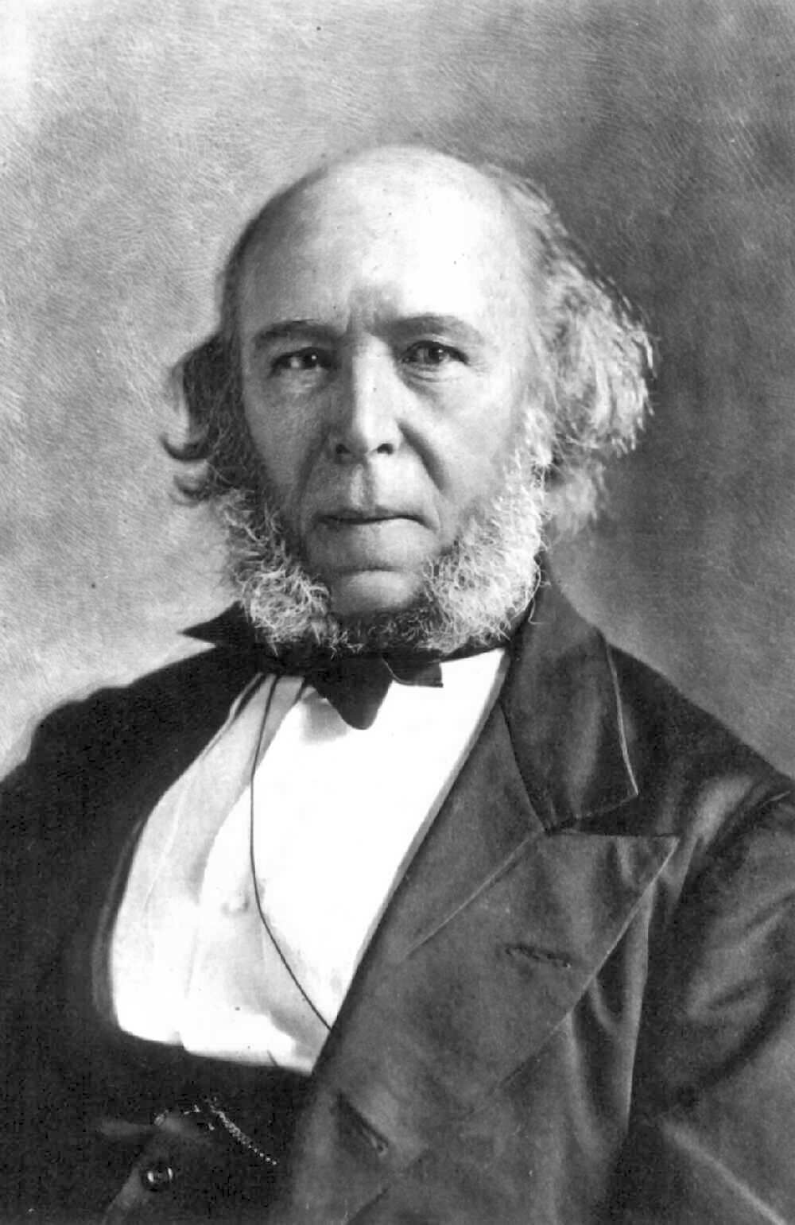
“The survival of the fittest”, a famous quote many know, but a fact many seem to miss is that the phrase was first coined by the famous philosopher, anthropologist, and sociologist Herbert Spencer. Spencer was a major figurehead during the Victorian era. He was born in England on April 27th, 1820 and died on December 8th, 1903. He was most famous for applying Charles Darwin’s theory of evolution into society stating that society is like an organism and like animals, society will naturally evolve and grow. His evolutionary stance led to the famous idea of ‘Social Darwinism’.
Charles Darwin first introduced the theory of evolution saying that animals change naturally. Spencer took that theory further and applied it to society saying that society will naturally change and evolve over time. For this, Spencer did not see a need to go out and improve or change society as it was bound to change automatically. He would compare society to an organism and would maintain that like organisms, society would start off simple and then over time progress to becoming more complex. Spencer went further on as to say there were more similarities between animal organisms and societies in that they both had three main systems. The first would be the regulative system. In animals that would be the central nervous system and in society it would be the government that regulates everything. Next was the sustaining system. In animals that would be the giving and receiving of nourishment and in society it would be the industry (jobs, money, economy). The last was the distributive system. In animals that would be the veins and arteries and in society it would be roads, transportation, internet, and anywhere where goods and information would be exchanged.
It was not Darwin but rather Herbert Spencer who coined the term “survival of the fittest”. Spencer used that term in relation to society as to say that the reason the rich and powerful became so because they were better suited to the social and economic climate at the time. He believed it was natural that the strong survive at the cost of the weak.
Spencer’s thinking is what influenced the idea of the structural-functional perspective. Basically he means that society is divided up into several different structures or parts and each has its own function or job to perform. If all parts are performing their function correctly, then society as a whole runs stable and smooth. Spencer went on to say that this perspective is like that of the human body. The body is made up of three main parts; the skeleton, the muscles, and the internal organs. Each of these structures perform a function and the body runs smoothly if all structures a performing their necessary functions correctly. However, if one structure doesn’t perform correctly then the body as a whole becomes affected.
Today, we live in a very complex society. But if Spencer’s theory is to be believed, then this society started off as something very simple with only a few rules and regulations and evolved into the complex society that we see today. Through history we know how Canada was discovered and how it operated under British rule at that time. It was an easy to understand the structure then but now Canada has evolved so much it has many different structures playing a part and it’s not necessary for the common people to know and understand the function of everything.

Questions
- Spencer first popularized his theory of how societies evolve and grow in the late mid-1800’s. How has society evolved from the time of his death in 1903 to now?
- How does the term “survival of the fittest” fit in relation to society?

