Alannah Walker
Ms. Rizzuti
HSP3C
October 23, 2015

Cognitive Development
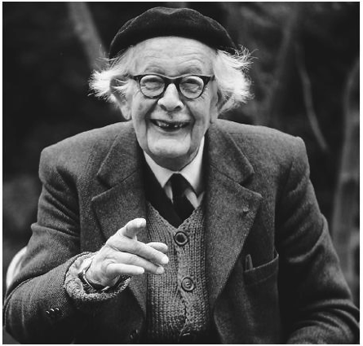
Jean Piaget’s Study on Children’s Ability to Learn
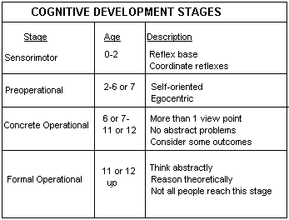
J
ean Piaget was born in Nuchatel, Switzerland on August 9th, 1896. He was married to Valentine Chatenay, they had three children, two daughters and a son. Jean's parents were Arthur Piaget and Rebecca Jackson, a smart and outgoing woman. Jean's mother first sparked his passion for psychology. Piaget earned many honorary degrees, because of the positions he held in his time. Jean Piaget's main focus was the development of thinking. Since there were no other psychologist studying this area of science, he got the honor of giving it a title. He named it Genetic Epistemology. September 16th, 1980 Piaget passed away in Geneva with over sixty books and hundreds of articles published.

In the 1920s Piaget went to France, he gained a significant amount of knowledge with the development of a child’s ability to learn, due to working on a theory by testing children’s aptitudes and abilities. Piaget continued to see the same pattern in children’s answers to a selection of questions. These children consistently made distinct mistakes that’s elders wouldn’t. A good example of the difference of perception and interpretation between a child and adult would be: “children have a hard time understanding that two different sized bottles can have the same amount of water in them”.

Being human Jean Piaget believes we all go through four stages of Cognitive Development, and intellectual progression. According to Piaget, as we mature, as we grow, naturally our mind creates Schemas (“mental frame works that help interpret information”) (video). You can describe a schema as you would a concept. He proposes that we become accustom to new objects, experiences, environments or people through two similar processes which are: Assimilation and Accommodation.

Assimilation “dealing with a new event in a way that is consistent with an existing schema.” (The Growth of Knowledge) For example, a child calls a deer horse because that’s how it appears to her knowledge. But as we get older, and our minds grow, we learn to adapt to new objects, environments, experiences and more. Accommodation “is the process of dealing with new information or events, by both modifying an existing schema forming a new one.”( The Growth of Knowledge) For example “the child realizes deer and horses are not the same, now her schema will adjust.”( The Growth of Knowledge)

In the first stage of Cognitive Development it starts from the day you are born, until about the age of two. Piaget called this the Sensorimotor stage which focuses on a child’s motor skills, actions and senses. At this stage children live in the here and now, and if it’s not visible it’s irrelevant. Piaget referred to this as Objective Permanence “the awareness that things still exist when they are no longer in sight.”( The Growth of Knowledge) Because we grow so fast, Piaget considers Objective Permanence a “huge accomplishment in this stage.”( The Growth of Knowledge)

The second stage of Cognitive Development is the Preoperational Stage. This stage continues from age two to around six or seven. While a child goes through this stage they start to recognize objects and events. Only their thoughts, wants and needs matter. Children behave this way due to Egocentrism, which stays with us forever, but usually inspires a child’s thoughts or cannot process another person perspective. For example, if you ask a child what someone else see from another side of the room, the child will think they can see the same as he or she can. But in reality the other child cannot see the exact same things.

The third stage of development, is the Concrete Operations Stage. This stage starts from the ages six or seven to about eleven or twelve years old. By now, the child should recognize, use symbols correctly and “conserve numbers. Conservation refers to the idea that the quantity remains the same despite changes in appearance.” (Piaget, 5/8) For example, if you show a child five coins in a row, then show them spread out, the child will know that the coins in each row amount to the same value. Jean Piaget used a few techniques in this stage. Classification and Serration are also learned in the Concrete Operations Stage. Classification “refers back to the questions of whether there are more marbles than black marbles.” (Piaget 6/8) A set of marbles can include another kind or colour of marbles. Serration is “putting things in order,” (Piaget, 6/8) becoming organized.

The last stage of Cognitive Development, is the Formal Operations stage. This stage starts from twelve years old through the rest of your life. In this stage a child’s mind matures significantly. Piaget believes that children start demonstrate logical operations, and using them “abstractly, rather than concrete.”(Piaget, 6/8) This is referred to as Hypothetical Thinking (“able to think logically, and abstractly and theoretically.”) This is known to be the PRIME development stage in an individual’s life. Children become independent, and initiate ambition to succeed in life. Jean Piaget does not believe everyone gets to the formal operations stage of development.

Jean Piaget’s theory can still be used in everyday life either now or then. His theory is based on personal and social development. Every child that is born demonstrates their sensorimotor skills first before anything, its natural and that will never change. The only thing stopping a child from touching, grasping, latching etc.. would be some form of disability and such. When we hit the age of six or seven, kids do act or feel that their point of view is all that is relevant or it’s what they understand. Also when he hit our teens we are aware of what’s going on around us, we take in information that we learned throughout the years and we apply it to are daily tasks or goals. Jean Piaget’s theory is more of an explanation to how we think how we grow how we develop the ability to learn. And everything he states in his theory is quite clear and correct. Children see things and think that it’s the same thing as something else (Schema), then children start to realize that things can look similar but still be different (Assimilation). Which leads a child to then adjust their schema forming a new one (Accommodation). Every day we grow and every day we learn new things, how could his theory not apply to today’s views in life.

http://webspace.ship.edu/cgboer/piaget.html
Child Development-piaget's theory of cognitive development. (n.d.). Retrieved October 13, 2015.
Boeree, C. George. "Piaget." Piaget. N.p., n.d. Web. 15 Oct. 2015.

https://www.youtube.com/watch?v=cnGM6W4DHEo
Child Development-piaget's theory of cognitive development. (n.d.). Retrieved October 13, 2015.
"Child Development-piaget's Theory of Cognitive Development." YouTube. YouTube, 19 June 2015. Web. 15 Oct. 2015.

http://www.muskingum.edu/~psych/psycweb/history/piaget.htm
Child Development-piaget's theory of cognitive development. (n.d.). Retrieved October 13, 2015.
"Jean Piaget." Psychology History. N.p., n.d. Web. 15 Oct. 2015.

https://www.youtube.com/watch?v=8nz2dtv--ok
Child Development-piaget's theory of cognitive development. (n.d.). Retrieved October 13, 2015.
"The Growth of Knowledge: Crash Course Psychology #18." YouTube. YouTube, June-July 2014. Web. 15 Oct. 2015.

My Questions To You
- How do you feel about piagets theory, do you think that all babies start with sensori motor skills?

- If you were to compare any of these stages to your life, could you say or remember thinking that a deer was a horse or that all marbles are marbles and can be different colours and sizes?

- do you remember the last schema that you had to adjust due to cognitive development.

