Lotta Charity
Ms. Rizzuti
HSP3C
October 22, 2015
DR. Julia Hare A.K.A the Female Malcom X

Dr. Julia Hare was born in Tulsa, Oklahoma, she is an educational psychologist, relationship
expert, social commentator that has been regarded as one of the most dynamic motivational speaker on
a national podium today, she has been dubbed by the largest black newspaper in London “The Voice” as
“The female Malcom X” and “she is setting the black world on fire”. Dr. Julia Hare was a speaker at the
State of Black Union Conference in 2007 electrifying the audience with her views on the difference
between being a black leader and leading blacks. Dr. Julia Hare has written books such as “The
Endangered Black Family: Coping With the Unisexualization and Coming Extinction of the Black Race”,
“How to Find and Keep a BMW: Black Man Working” and “The Miseducation of the Black Child”.

Dr. Hare has a theory, that the black community need to go back and reclaim the minds of our
children, because the powers that be (government) have come into black home’s and started tell us that
we cannot discipline our children anymore, meaning if your child does not listen or is acting up, you are
not allowed to spank your children, and if you do discipline you child in this manner you will be sent to
jail. Dr. Hare also goes on to speak about how they have also taken discipline out of the schools and
when they act up, they end up putting our black children into ESL classes because the teacher have no
authority to do anything and don’t want to deal with these troubled and undisciplined black children. In
Dr. Hare’s eyes, those ESL classes are nothing but holding cell’s until they can be shipped off to the
federal prison, and then once you put them into prison you can convict them of a felony, then once they
are convicted of a felony they do their time, they get out of prison, some of them cannot find jobs
because they are not bondable, meaning, they cannot be insured by the hiring company, if something is loss or stole by an employee the company ins insured for the value of the loss. Let’s just say they happen to luck out they have to pay taxes on a job but they cannot vote (American Voting Law), Dr. Hare calls this “Taxation without Representation”.

____________________________________________________________________________________
Dr. Hare believes that they did a big thing by removing discipline from our homes and schools, because when they made the parents afraid to discipline the children, we started to find out that the teachers are afraid of the principal, the principal is sacred of the superintendent, the superintendent is afraid of the of the school board, the school board is afraid of the parents, the parents are afraid of the children, and the children aren’t afraid of anybody. Some people have the view that some of our black children are hopeless, and they will never amount to anything but it all comes back down to parents and discipline, taking discipline out of black home was if not the worst thing that could have been done, the children seem to have more authority then teachers and parents and they don’t care because there are consequences for their actions, especially in the black family were there a target painted on their backs, black males make up 69% of the prison population most of this could have been avoided if discipline wasn’t removed from black families.
Even though Dr. Hare is a American psychologist I feel like we still have these exact same problems in Canada even though it is 2015, we are not allowed the discipline without fear of being charged, a really good example of this was when the riot was happening in Ferguson, a mother had tracked her son down that part of the looting, on national television she basically started disciplining, hitting and screaming at him trying to get him to leave, everybody was applauding her for being a mother and doing exactly what a mother that loves her child should do, but what happen, instead of say good job mom child services was called as well as the police. Another perfect example of this is my nephew16 years old he was not listening he wanted to do his own thing, he thought he was a grown up did want to follow the rules, one day he want way too far and my sister disciplined him by smacking him in the back of the head which in my opinion he deserved it, well the next day his school had call my sister inquiring what had happened. Not if discipline was allow this whole situation with my nephew would of never of happened.
Review Questions
1) “The Voice” dubbed Dr. Julia Hare what title? Explain why you think they gave her that name?
2) Dr. Julia Hare has very strong views on the state of a black house hold, give two of her views and explain why do you think she feels so strongly?
3) What are some of Dr. Julia Hare’s views on discipline and the school system?
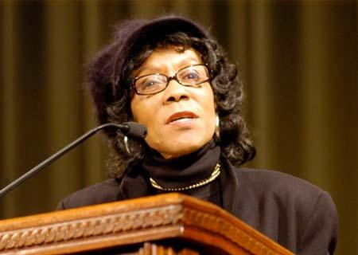

Works Cited
Author, A. (date). Title of Article. Title of Website. Retrieved from http://www.thehistorymakers.com/biography/Julia-Reed-hare-38
Author, A. (date). Title of Article. Title of Website. Retrieved from
http://aalbc.com/author/nathan-julia hare.htm
Author, A. (date). Title of Article. Title of Website. Retrieved from
http://blackbirdpressnews.blogspot.ca/2013/04/stanford-university-ponders-dr-nathan.html
Author, A. (date). Title of Article. Title of Website. Retrieved from
http://www.apbspeakers.com/speaker/julia-hare

