“Moral Behaviour in Animals”- HSP3C Responding
https://www.ted.com/talks/frans_de_waal_do_animals_have_morals#t-77967
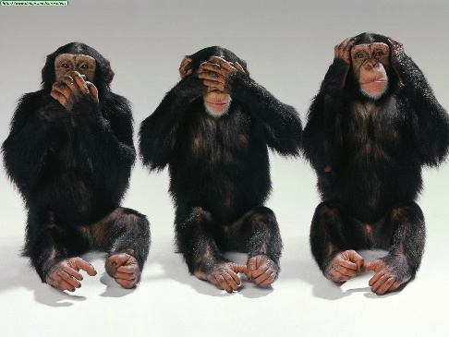
Many people believe that our moral belief system comes from a sense of religion and/or clear moral upbringing and that humans would not have a sense of morality if they did not ‘learn’ it. People wanted to know if this is actually true and turned to animals to see if they have a sense of morality – as this would give humans more insight into if we are also ‘born’ with an ingrained sense of morality.

Answer the following questions in relation to the video shown in class:
- What assumptions do we have about animals and how they behave in relation to morality? (approx. 4-5 sentences)

- What are the pillars of morality? (1-2 sentences)

- What did you learn about how animals behave together in relation to morality? How do these findings relate to our understanding of humans and our sense of morality? (Discuss at least two main points from the video) (approx. 8 sentences or more)

Key Definitions from the video:
Reciprocity the practice of exchanging things with others for mutual benefit, especially privileges granted by one country or organization to another.
Empathy the ability to share and understand the feelings of another

