Fayyaadh Chady
Ms. Rizzuti
HSP3C
October 22, 2015

Theory on Language Acquisition

Noam Chomsky is a psychologist who was known for his ground breaking contributions to linguistics. Born in Philadelphia on December 7, 1928, Noam Chomsky was considered a brilliant child. He acquired a PhD in linguistics at the University of Pennsylvania. At the age of ten, Chomsky wrote an editorial on the rise of fascism in Europe after the Spanish Civil War for the school newspaper which later became the basis for an essay that he would present at New York University. In 1949, Noam Chomsky married Carol Schatz an educational specialist, a woman he had known since childhood, for fifty-nine years until she passed away. Since 1955, Noam Chomsky has been a professor at Massachusetts Institute of Technology (MIT) and has produced ground-breaking, controversial theories on human linguistic capacity. He is also a well published author, with work published in his field as well as in U.S foreign policy. Noam has amassed a wealth of academic and humanitarian awards, including the Distinguished Scientific Contribution Award from the American Psychological Association, the Kyoto Prize in Basic Sciences and the humanitarian Sydney Peace Prize. He was widely considered to be the father of modern linguistics.

One of his theories that is the most relevant and famous is the theory of linguistic acquisition. For many years, the linguistics have battled over whether language acquisition is innate or something that is learned. Noam Chomsky believed that the basic concepts of language were innate in every human’s mind and then influenced by one’s environment. Chomsky had used a few factors to support his theory. First, there is an optimal learning age. A child is most likely to learn a language completely and grasp fluency between the ages 3 to 10. After this age it is hard and even considered impossible for the child to completely grasp the language.

According to Chomsky’s theory, the second factor is that language acquisition does not need to be triggered for it to begin, it will happen on its own. The parents do not need to influence the kid to speak. If it’s around the time for language production, the child will work to produce that language on its own. There are several things that may help the child develop faster, the parents producing baby talk, or being read to on a consistent basis. But Chomsky believed that these things only have a small effect. If not done, the child will still learn to speak without them.

Another factor found by Chomsky was that it does not matter if a child is corrected, they still grasp the language in the same manner and speak the same way. He stated that during one stage, a child will make things plural that are already plural. They will say geeses instead of geese. In one of his documented case, a mother corrected her child several times to say feet instead of feets, she looked at her mother, said “ohh”, as if she understood and proceeded to say feets. Another fact by Chomsky is that children go through stages of language acquisition where they learn certain parts of the language. Children all around the world go through these stages at the same time, around the same age. A child in China and a child in U.S will follow the same linguistic patterns of language acquisition. With these observation as well as knowledge about neurological structures that control linguistic communication and interpretation, that Noam Chomsky argues that language is innately organized.

Noam Chomsky believes that children are born with an inherited ability to learn any human language. According to Chomsky, in order for knowledge to be retained, there must be previous knowledge already present for the new information to be associated with. Chomsky also points out that a child could not possibly learn a language through imitation alone because the language spoken around them is irregular. In today’s society, our school systems are being criticized for teaching foreign languages in high school and not in elementary, which according to Chomsky’s first factor, the optimal learning age, which states that a child is most likely to learn a language in its completeness between the ages 3 to 10. And that after this age it is hard and even considered impossible for the child to completely grasp the language.
In conclusion Noam Chomsky believes that language is something that all human beings are born with and that it’s all influenced by our environment. Chomsky suggested a few factors to support his theory, the optimal learning age, learning acquisition happens on its own and it doesn’t matter if a child is being corrected or not. And according to Chomsky, every child around the world go through these stage at the same time, around the same age.

Questions
1) Would you agree that it is hard/impossible to learn a new language after the age of 10?
2) How does Noam Chomsky theory differ from that of B.F Skinner’s?
3) Do you agree with his theory (Yes or No) and why?

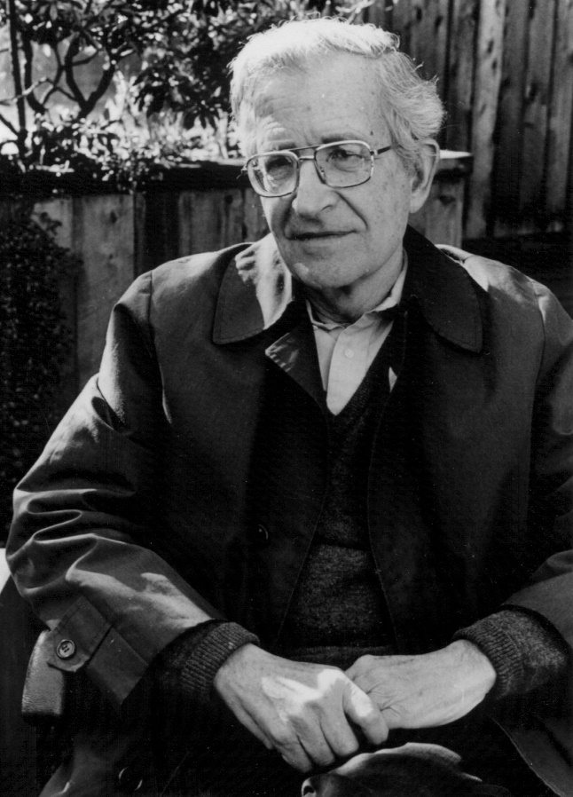
Works Cited

Biography.com Editors, Noam Chomsky Biography, The Biography.com website, http://www.biography.com/people/noam-chomsky-37616

Elizabeth Crabtree, May 1999, Noam Chomsky, Department of Psychology, http://www.muskingum.edu/~psych/psycweb/history/chomsky.htm

Edited April 30 2013, The Educational Theory of Noam Chomsky, New Foundations, http://www.newfoundations.com/GALLERY/Chomsky.html

Vandana Singhal, Updated February 3 2012, Chomsky's Theories on Language, Bright Hub Education, http://www.brighthubeducation.com/language-learning-tips/71728-noam-chomsky-language-acquisition-theories/

