Sensation & Perception
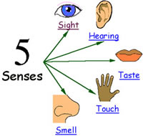
Sensation refers to the process of sensing our environment through touch, taste, sight, sound, and smell. This information is sent to our brains in raw form where perception comes into play. But perception is the way we interpret these sensations and therefore make sense of everything around us.
____________________________________________________________________________________
Sensation is the process by which our senses gather information and send it to the brain. A large amount of information is being sensed at any one time such as room temperature, brightness of the lights, someone talking, a distant train, or the smell of perfume. With all this information coming into our senses, the majority of our world never gets recognized. We don’t notice many things (e.g. radio waves, x-rays, or the microscopic parasites crawling on our skin). We only sense those things we are able too (e.g. different from bloodhound or a hawk).
Absolute threshold is the point where something becomes noticeable to our senses. It is the softest sound we can hear or the slightest touch we can feel. Anything less than this goes unnoticed.
e.g. noticing your heart beat, bug landing on your skin, when you begin to notice a song playing in the background
Difference threshold is the amount of change needed for us to recognize that a change has occurred (e.g. the sound of the radio becoming louder), noticing when light changes from afternoon to evening, a motorcycle coming closer, change in smell as you are approaching home (cooking)
Signal detection when we attempt/detect what we want to focus on and ignore or minimize everything else. (e.g. when on the phone and ignoring others, trying to recognize a song, trying to recognize a sound in a forest, when trying to find a new place and you turn down the radio on the car)
Sensory adaptation stimuli which has become redundant or remains unchanged for an extended period of time. (e.g. when you hear someone talking and you tune out, not noticing noisy neighbours anymore)
__________________________________________________________________________________
Perception refers to interpretation of what we take in through our senses. The way we perceive our environment is what makes us different from other animals and different from each other.

Gestalt Principles of Grouping
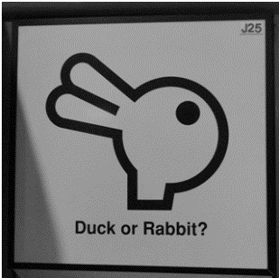
The German word “Gestalt” roughly translates to “whole” or “form,” and the Gestalt psychologist’s sincerely believed that the whole is greater than the sum of its parts. In order to interpret what we receive through our senses, they theorized that we attempt to organize this information into certain groups. This allows us to interpret the information completely without unneeded repetition. For example, when you see one dot, you perceive it as such, but when you see five dots together, you group them together by saying a “row of dots.”

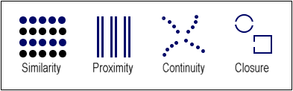
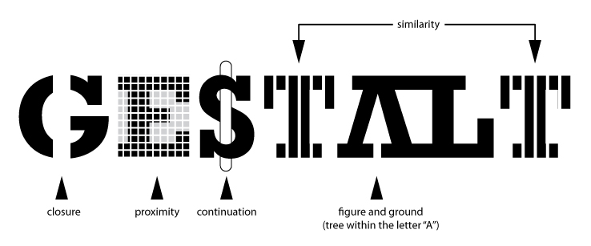

Maintaining Perceptual Constancy
Imagine if every time an object changed we had to completely reprocess it. Luckily, this doesn’t happen. Due to our ability to maintain constancy in our perceptions, we see a building as the same height no matter what distance it is. Perceptual constancy refers to our ability to see things differently without having to reinterpret the object’s properties. There are typically three constancies discussed, including size, shape, brightness.
Size constancy refers to our ability to see objects as maintaining the same size even when our distance from them makes things appear larger or smaller. This holds true for all of our senses. As we walk away from our radio, the song appears to get softer. We understand, and perceive it as being just as loud as before.
Everybody has seen a plate shaped in the form of a circle. When we see that same plate from an angle, however, it looks more like an ellipse. Shape constancy allows us to perceive that plate as still being a circle even though the angle from which we view it appears to distort the shape.
Brightness constancy refers to our ability to recognize that color remains the same regardless of how it looks under different levels of light. That deep blue shirt you wore to the beach suddenly looks black when you walk indoors.

