The Hastorf and Cantril Case Study- “They Saw a Game”
In selective group perception, people tend to actively filter information they think is irrelevant. This effect is demonstrated in Hastorf and Cantril’s

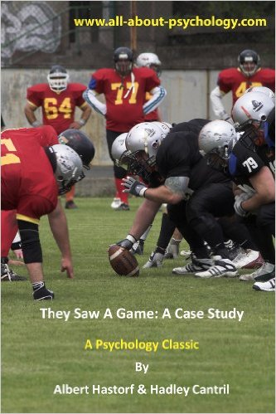
Background of the Study
Hastorf and Cantril’s case study analyzed what proved to be selective group perception of a football game contested between the Dartmouth Indians and Princeton Tigers. The football game the students watched had been played in 1951, and in that game Princeton won. It was a tough game, with a lot of penalties and caused uproar in series of editorials in campus newspapers.
The Princeton quarterback, who is an All-American, in his last game for college, left the game in its second quarter with a broken nose and a mild concussion. When third quarter came, Dartmouth quarterback ended up with a broken leg after being tackled in the backfield.

Methodology
A week after the game, Hastorf and Cantril asked both Dartmouth and Princeton students of psychology to answer a questionnaire. The researchers then analyzed and interpreted the answers of those who had seen the game either in real or in a recorded movie. They had two other groups view a film of the game and then tabulated the number of infractions seen.

Results
The Dartmouth and Princeton students noticeably had varying responses. When asked who started the rough play, almost no one said that Princeton did. Furthermore, 36% of the Dartmouth students and 86% of the Princeton students said it was Dartmouth who started it. On the other hand, 53% of the Dartmouth students and 11% of the Princeton students that both did start it.
In detail, here are the questions and the respective tallied answers from Dartmouth students and Princeton students:

"Which team do you feel started the rough play?"
 | Percent Dartmouth Students | Percent Princeton Students
Princeton started it | 2 | 0
Both started it | 53 | 11
Dartmouth started it | 36 | 86
Neither / no answer | 9 | 3
"Do you believe the game was clean and fairly played or that it was unnecessarily rough and dirty?"
 | Percent Dartmouth Students | Percent Princeton Students
Clean & Fair | 13 | 0
Rough & Fair | 39 | 3
Rough & Dirty | 42 | 93
don't know | 6 | 4
After showing a film of the game, Princeton students ‘saw’ the Dartmouth team make over twice as many rule violations as were seen by Dartmouth students. The researchers interpreted this as a manifestation of selective group perception. They interpreted these results overall as indicating that, when encountering a mix of occurrences as complex as a football game, we experience primarily those events that fulfill a familiar pattern and have a personal relevance to us.
For the students of each school, the selective group perception and memory of what might seem to be the same event involved a very active construction of different realities. Our membership in a group often provides us a frame and a filter through which we view social events, skewing our perceptions.
The said game definitely left a mark on the students from both schools, marked by different views also to those people who felt no allegiance to either of the teams. And even those belonging to the same group, the game meant different things to the team members and their fans. This particular case study demonstrates the crucial role of values in shaping one’s perception and judgment.

Conclusion
Albert Hastorf and Hadley Cantril’s case study was published in the Journal of Abnormal and Social Psychology in 1954. In conclusion, the experiment was used as evidence that ‘out of all the occurrences going on in the environment, a person selects only those that have some significance for him from his own egocentric position in the total matrix, that ’the game actually was many different games’ and that each version of the events that transpired was just as true and real to a particular person, as other versions were to other viewers and fans.
In this study, it was found that the participants’ perceptions were skewed and were easily influenced by their motives, unawaringly. It just proves that people sometimes only see what they want to see.
The researchers arrived at the following conclusion: "In brief, the data here indicate that there is no such 'thing' as a 'game' existing 'out there' in its own right which people merely 'observe.' The game 'exists' for a person and is experienced by him only insofar as certain happenings have significances in terms of his purpose."

Application
How does the phenomenon of selective group perception apply to our daily lives? While it is difficult to control our biases, it is imperative that we become knowledgeable at least of tendencies such as this. We need to become aware as well, that the impact of such social influence may be held to take the form of a shift in perspective.
A good way of countering this is to be sympathetic or to try and put ourselves into someone else’s shoes so as to see their own perspective. This way, we can see situations more comprehensively, objectively and more justly.

Sources
Selective Group Perception. They Saw a Game: A Case Study by Hastorf and Cantril

