Theories of Emotion
Emotion is a complex, subjective experience accompanied by biological and behavioral changes. Emotion involves feeling, thinking, activation of the nervous system, physiological changes, and behavioral changes such as facial expressions. Different theories exist regarding how and why people experience emotion. These include evolutionary theories, the James-Lange theory, the Cannon-Bard theory, Schacter and Singer’s two-factor theory, and cognitive appraisal.

- Evolutionary Theories
More than a century ago, in the 1870s, Charles Darwin proposed that emotions evolved because they had adaptive value. For example, fear evolved because it helped people to act in ways that enhanced their chances of survival. Darwin believed that facial expressions of emotion are innate (hard-wired). He pointed out that facial expressions allow people to quickly judge someone’s hostility or friendliness and to communicate intentions to others.
Recent evolutionary theories of emotion also consider emotions to be innate responses to stimuli. Evolutionary theorists tend to downplay the influence of thought and learning on emotion, although they acknowledge that both can have an effect. Evolutionary theorists believe that all human cultures share several primary emotions, including happiness, contempt, surprise, disgust, anger, fear, and sadness. They believe that all other emotions result from blends and different intensities of these primary emotions. For example, terror is a more intense form of the primary emotion of fear.

- The James-Lange Theory
In the 1880s, two theorists, psychologist William James and physiologist Carl Lange, independently proposed an idea that challenged commonsense beliefs about emotion. This idea, which came to be known as the James-Lange theory, is that people experience emotion because they perceive their bodies’ physiological responses to external events. According to this theory, people don’t cry because they feel sad. Rather, people feel sad because they cry, and, likewise, they feel happy because they smile. This theory suggests that different physiological states correspond to different experiences of emotion.

- The Cannon-Bard Theory
The physiologist Walter Cannon disagreed with the James-Lange theory, posing three main arguments against it:
- People can experience physiological arousal without experiencing emotion, such as when they have been running. (The racing heart in this case is not an indication of fear.)
- Physiological reactions happen too slowly to cause experiences of emotion, which occur very rapidly. For example, when someone is in a dark alley alone, a sudden sound usually provokes an immediate experience of fear, while the physical “symptoms” of fear generally follow that feeling.
- People can experience very different emotions even when they have the same pattern of physiological arousal. For example, a person may have a racing heart and rapid breathing both when he is angry and when he is afraid.
Cannon proposed his own theory of emotion in the 1920s, which was extended by another physiologist, Philip Bard, in the 1930s. The resulting Cannon-Bard theory states that the experience of emotion happens at the same time that physiological arousal happens. Neither one causes the other. The brain gets a message that causes the experience of emotion at the same time that the autonomic nervous system gets a message that causes physiological arousal.

Schachter and Singer’s Two-Factor Theory

In the 1960s, Stanley Schachter and Jerome Singer proposed a different theory to explain emotion. They said that people’s experience of emotion depends on two factors: physiological arousal and the cognitive interpretation of that arousal. When people perceive physiological symptoms of arousal, they look for an environmental explanation of this arousal. The label people give an emotion depends on what they find in their environment.

Example: If a person finds herself near an angry mob of people when she is physiologically aroused, she might label that arousal “anger.” On the other hand, if she experiences the same pattern of physiological arousal at a music concert, she might label the arousal “excitement.”

Schachter and Singer agree with the James-Lange theory that people infer emotions when they experience physiological arousal. But they also agree with the Cannon-Bard theory that the same pattern of physiological arousal can give rise to different emotions.

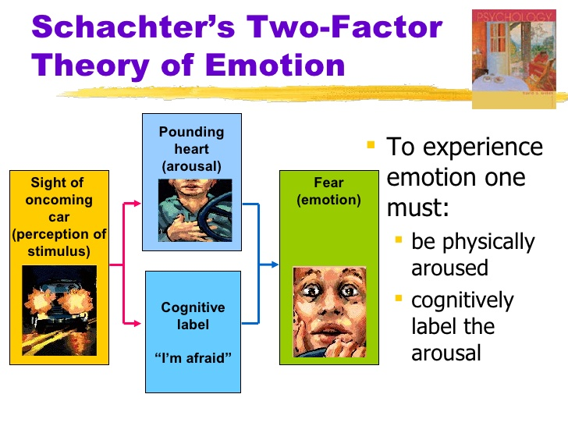

Cognitive Appraisal
The psychologist Richard Lazarus’s research has shown that people’s experience of emotion depends on the way they appraise or evaluate the events around them.

Example: If Tracy is driving on a winding road by the edge of a high cliff, she may be concerned about the danger of the road. Her passenger, on the other hand, thinks about the beauty of the view. Tracy will probably feel frightened, while her passenger may feel exhilarated.

