Unit 1 Project
HSP3C

TASK: To create a written report based on research of a social scientist. This research will focus on finding information about ONE particular/specific theory that the social scientist of your choosing came up with. Then students will create some Thinking questions they have about individuals in society that are inspired by the theory proposed by their social scientist. Students will report and post their work for their teacher and classmates. Next students will respond to 2 Key Thinking questions provided by their classmate’s and submit this to their teacher. (Further instruction on last step will be given).

Steps --- Complete in the following order.

Step 1- Choose your social scientist (anthropologist, psychologist or sociologist).

Step 2- Begin conducting research on your social scientist. Choose only the most reputable sources. You need to consult a minimum of 4 different sources. Create pages of jot notes as you are researching to summarize information in your own words. (Attach them to your final work). You will also need to attach a Works Cited Page in APA format.

Step 3- You will create a report to summarize and describe what you found out about ONE of your social scientist’s key theories. Your report should be approx. 1 ½-2 pages single spaced, 12 point font. Include one reasonably sized picture of your social scientist as well in your report.

1st paragraph—Provide a brief overview of who your social scientist is and what they are most famous for, when they were alive, etc.

2nd -4th paragraphs—Summarizing and describing in your own words the ONE theory of your social scientist’s that you researched and focused on.

5th paragraph/section** Most important—Describe how your social scientist’s theory can relate to our understanding of Canadian society TODAY in 2015. Consider that our world has changed in terms of how the ‘majority’ of society views certain topics/ideas. How do we understand your social scientist’s theory when we apply it to our society now? What things would we have to consider? In other words, discuss how your social scientists findings have contributed or impacted Canadian society - how are they relevant to the way we live today as individuals, as a group within Canadian society, or to Canadian society as a whole.

You will also include 3 solid KEY THINKING QUESTIONS that you could ask/pose to suggest your classmates to help them think about how we could consider applying your social scientist’s theory to our world today. (e.g. If you were focusing on Freud, you might ask – “If Freud thought our childhood experiences have a large impact on who we are, then what might he say about how in today’s society, childhood bullying is more prevalent and how it affects the child’s personality?”

Step 4- You will then post your report. (Teacher will give details of how/when at a later date). You will answer 2 different Key Thinking Questions provided by 2 different classmates. Each answer should be a minimum of 200 words.

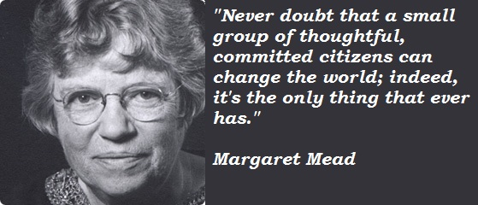

List of Leading Social Scientists (just do not choose Sigmund Freud!)

Dian Fossey
Franz Boas
Auguste Comte
Noam Chomsky
Emile Durkheim
Erik Erikson
Karen Horney
Carl Jung
The Leakeys (Louis, Mary, and Richard)
Harriet Martineau
Karl Marx
Margaret Mead
Lewis Henry Morgan
Talcon Parsons
Ivan Pavlov
Jean Piaget
Max Weber
Dorothy E. Smith
Herbert Spencer

Ask permission for any additional Social Scientist not listed.

Please see the checkbric below to know exactly how you are being evaluated and ATTACH it to your assignment.
Categories | Level 1 –  50-59%  (Below Expectations) | Level 2-  60-69%  (Approaching Expectations) | Level 3-  70-79%  (Meeting Expectations) | Level 4-  80-100%  (Above & Beyond Expectations)
Knowledge of social scientist is thorough consulting a minimum of 4 reputable sources in relation to:
a) background knowledge
b) ONE key theory the social scientist is known for
/10 marks
Thinking is strong in relation to a) the 3 KEY QUESTIONS student has created for their classmates
b) Answers to 2 different classmates’ key questions /10 marks
Communication is a) strong in relation to clearly discussing and summarizing the social scientist, their key theory and how this theory can be applied to Canadian society today
b) Edited and checked for correct spelling and grammar for easy reading
c) Follows the structure required for organization
/10 marks
Application of the social scientist’s theory is seen through the student’s discussion of how it can be related to Canadian society today
/10 marks
Total _______/40 marks =

