What Do You See? Initial Perception Test
What do I see? ________________________ What do others see? _____________

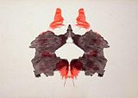 What do I see? ________________________ What do others see? _____________
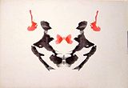 What do I see? ________________________ What do others see? _____________

What do I see? ________________________ What do others see? _____________
What do I see? ________________________ What do others see? _____________
What do I see? ________________________ What do others see? _____________

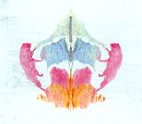 What do I see? _____________ ___________ What do others see? _____________

